**HTML & CSS - BASICS**

1. Create a basic html web structure by this image, use **Semantic Tags,** start

without styling until the footer and then start the styling on external css stylesheet file.

HTML & CSS Description:

-page background color is gray

-use header with navigation links-dark gray background color with white text and aligned

-from about us until the form including it background color should be white

-about us heading

-paragraph

-services heading

-unordered list

-a form with “Contact Us” heading

-4 inputs: name, email, message and submit

-footer - same style as the main heading

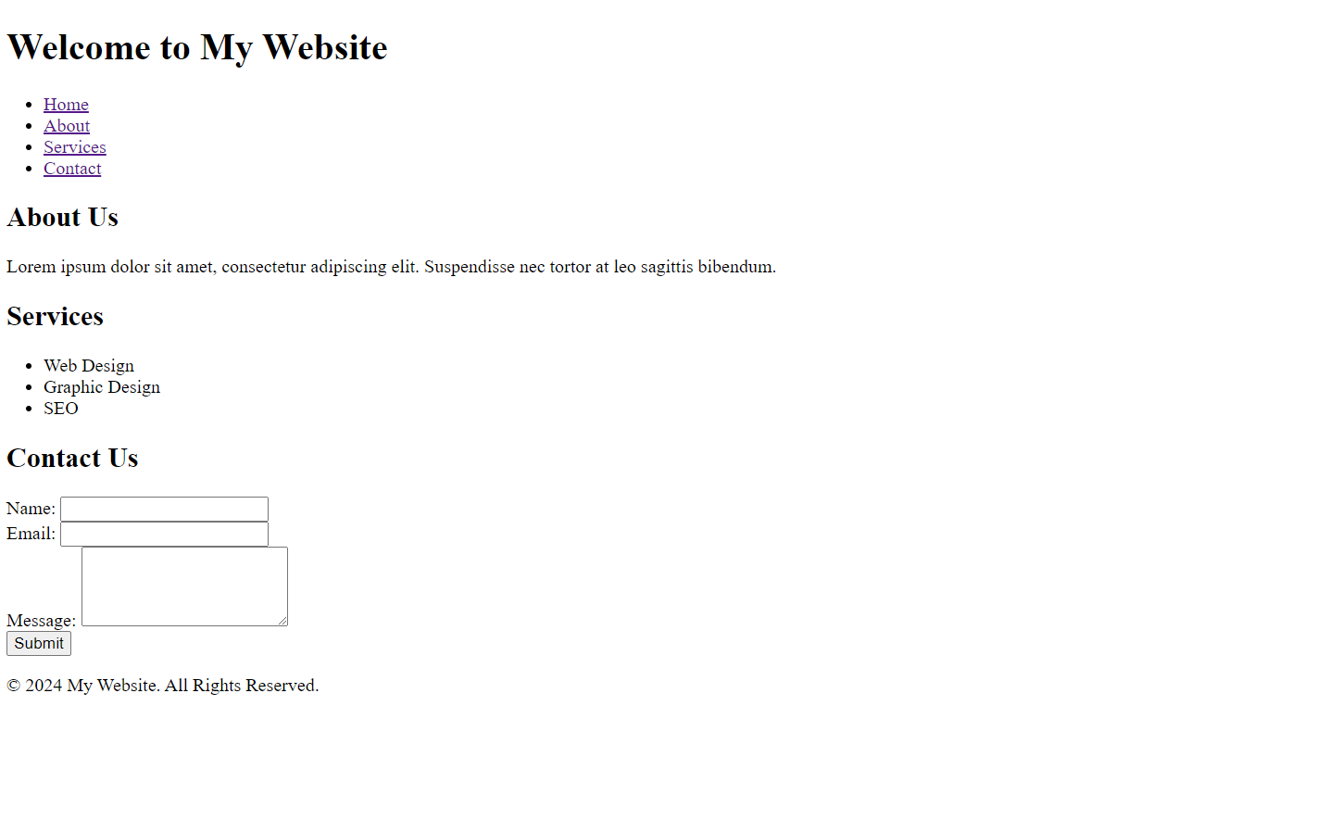

**Without Styling at all**

**With Styling**

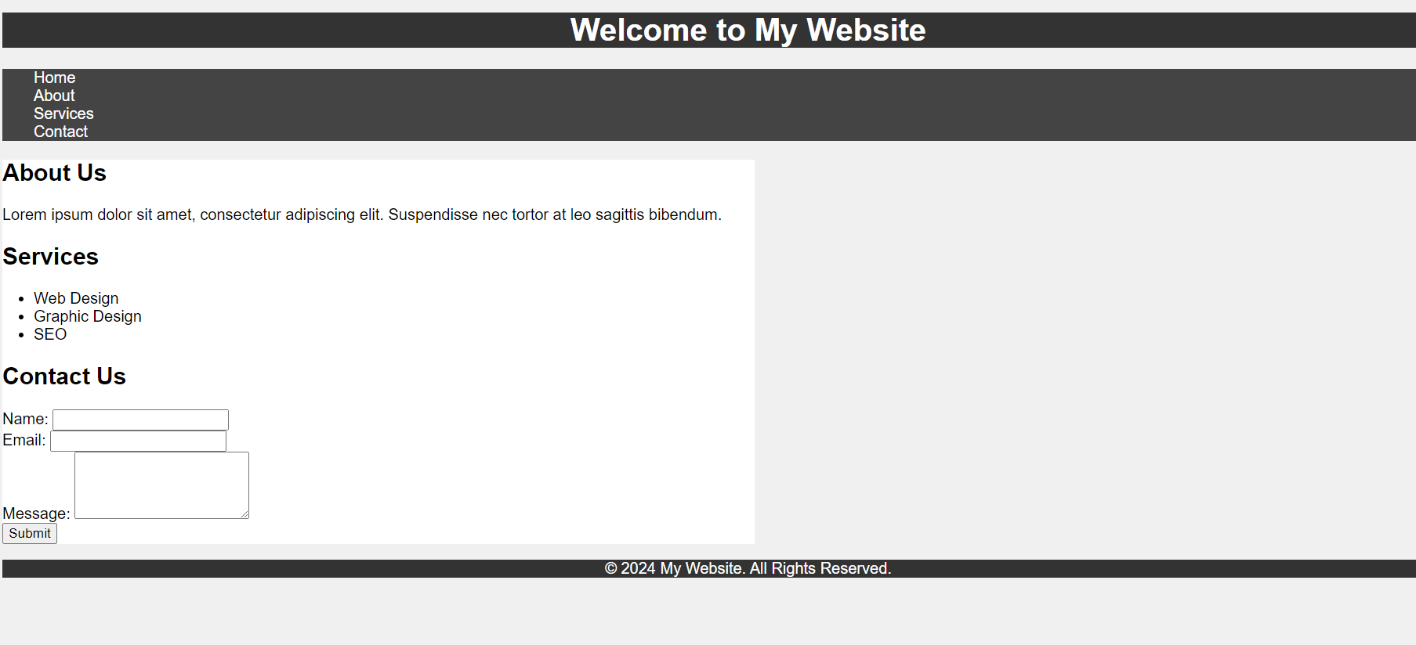

Copyrights © - All rights reserved to Spacode by Ben Efraimov